UNITED STATES
SECURITIES AND EXCHANGE COMMISSION
WASHINGTON, D.C. 20549

FORM 8-K

CURRENT REPORT
Pursuant to Section 13 or 15(d)
of the Securities Exchange Act of 1934

Date of Report (Date of earliest event reported): August 6, 2026

OCUGEN, INC.
(Exact name of registrant as specified in its charter)

Delaware |  | 001-36751 |  | 04-3522315
(State or other jurisdiction  of incorporation) |  | (Commission File  Number) |  | (IRS Employer  Identification No.)

11 Great Valley Parkway  Malvern, Pennsylvania |  | 19355
(Address of principal executive offices) |  | (Zip Code)

Registrant’s telephone number, including area code: (484) 328-4701

N/A
(Former name or former address, if changed since last report.)

Check the appropriate box below if the Form 8-K filing is intended to simultaneously satisfy the filing obligation of the registrant under any of the following provisions (see General Instruction A.2. below):

☐ | Written communications pursuant to Rule 425 under the Securities Act (17 CFR 230.425)
☐ | Soliciting material pursuant to Rule 14a-12 under the Exchange Act (17 CFR 240.14a-12)
☐ | Pre-commencement communications pursuant to Rule 14d-2(b) under the Exchange Act (17 CFR 240.14d-2(b))
☐ | Pre-commencement communications pursuant to Rule 13e-4(c) under the Exchange Act (17 CFR 240.13e-4(c))

Securities registered pursuant to Section 12(b) of the Act:

Title of each class |  | Trading  Symbol(s) |  | Name of each exchange  on which registered
Common Stock, par value $0.01 per share |  | OCGN |  | The Nasdaq Stock Market LLC  (The Nasdaq Capital Market)

Indicate by check mark whether the registrant is an emerging growth company as defined in Rule 405 of the Securities Act of 1933 (§ 230.405 of this chapter) or Rule 12b-2 of the Securities Exchange Act of 1934 (§ 240.12b-2 of this chapter).

Emerging growth company ☐

If an emerging growth company, indicate by check mark if the registrant has elected not to use the extended transition period for complying with any new or revised financial accounting standards provided pursuant to Section 13(a) of the Exchange Act. ☐

Item 2.02 Results of Operations and Financial Condition.

On August 6, 2026, Ocugen, Inc (the “Company”) issued a press release announcing certain financial results for the quarter ended June 30, 2026. The Company has scheduled a conference call and webcast for 8:30 a.m. Eastern Time on August 6, 2026, to discuss these financial results and business updates. The Company will use presentation materials in connection with the conference call and webcast, which presentation materials will be posted on the Company's website at www.ocugen.com. Copies of the press release and presentation materials are furnished herewith as Exhibit 99.1 and Exhibit 99.2, respectively, to this Current Report on Form 8-K (this “Report”) and incorporated herein by reference.

The information disclosed under Item 2.02 of this Report, including Exhibit 99.1 and Exhibit 99.2, is being furnished and shall not be deemed “filed” for purposes of Section 18 of the Securities Exchange Act of 1934, as amended (the "Exchange Act"), or otherwise subject to the liabilities of that section, and shall not be deemed to be incorporated by reference in any Company filing under the Securities Act of 1933, as amended (the “Securities Act”), or the Exchange Act, except as expressly set forth by specific reference in such filing.

Item 9.01 Financial Statements and Exhibits.

(d) Exhibits.

Exhibit Number |  | Description
99.1 |  | Earnings Press Release of Ocugen, Inc., dated August 6, 2026.
99.2 |  | Earnings Release Presentation of Ocugen, Inc., issued August 6, 2026.
104 |  | Cover Page Interactive Data File (embedded within the Inline XBRL document).

SIGNATURE

Pursuant to the requirements of the Securities Exchange Act of 1934, the registrant has duly caused this report to be signed on its behalf by the undersigned hereunto duly authorized.

 |  | OCUGEN, INC.
Date: August 6, 2026 | By: | /s/ Shankar Musunuri
 |  | Name: Shankar Musunuri
 |  | Title: Chairman, Chief Executive Officer, & Co-Founder

Exhibit 99.1



Ocugen Provides Business Update with Second Quarter 2026 Financial Results

Conference Call and Webcast Today at 8:30 a.m. ET

 | • | Received U.S. Food and Drug Administration (FDA) clearance to initiate OCU410 Phase 3 trial for geographic atrophy (GA), secondary to dry age-related macular degeneration (AMD); on track to initiate Phase 3 this quarter

 | • | Granted Regenerative Medicine Advanced Therapy (RMAT) designation by FDA for OCU410, enabling eligibility for priority review and accelerated approval

 | • | Signed a binding term sheet with Roots Pharmaceutical, and its strategic partner Al-Dhow International Holding, to negotiate an exclusive license for OCU400 in retinitis pigmentosa (RP) across the Middle East and North Africa (MENA) region

 | • | Successfully completed OCU400 Process Performance Qualification (PPQ) batches, supporting Biologics License Application (BLA) and commercial launch supplies

 | • | Closed $130.0 million convertible senior notes financing, extending cash runway into 2028

 | • | Remain on track to announce top-line results for two late-stage clinical programs, OCU400 for RP and OCU410ST for Stargardt disease in 1Q 2027 and 2Q 2027, respectively

 | • | Strengthened leadership team with the appointments of Mohamed Genead, M.D., M.Sc., as Chief Medical Officer and Chris Clark as Head of Corporate Communications

MALVERN, Pa., August 6, 2026 (GLOBE NEWSWIRE) -- Ocugen, Inc. (“Ocugen” or the “Company”) (NASDAQ: OCGN), a pioneering biotechnology leader in gene therapies for blindness diseases, today reported second quarter 2026 financial results along with a general business update.

“The second quarter of 2026 marked a pivotal inflection point for Ocugen. We closed $130 million convertible senior notes financing, extending our cash runway into 2028, and signed a binding term sheet for exclusive license of OCU400 in retinitis pigmentosa across the Middle East and North Africa region,” said Dr. Shankar Musunuri, Chairman, Chief Executive Officer, and Co-Founder of Ocugen. “Ocugen is a leading gene therapy company, focused on vision loss diseases with significant unmet medical needs, with multiple catalysts through 2028 across three distinct retinal disease indications. As we advance toward key data milestones in the first half of 2027, we remain focused on creating long-term value for our patients and shareholders.”

Unlike traditional gene therapies that correct a single mutation, Ocugen's modifier gene therapy platform targets master regulatory genes that control multiple gene networks of biological pathways, supporting a gene-agnostic approach applicable across a broad range of genetic mutations, as well as diseases with complex pathways such as dry AMD. This allows the Company to address large, underserved patient populations rather than narrow single-gene subsets. This platform underpins each of Ocugen's three late-stage programs, which advanced meaningfully during the quarter.

Clinical Program Updates

OCU410 (GA)

 | • | Received FDA clearance for the Phase 3 registrational trial (ArMaDa3) for GA secondary to dry age-related macular degeneration, anchored by positive 12-month Phase 2 ArMaDa data (statistically significant 31% reduction in GA lesion growth versus control [patient population: lesion size ≥2.5 mm2 and ≤17.5 mm2], p<0.05, at the optimal dose planned for Phase 3)

 | • | Planned combined global Phase 3 trial of approximately 237 subjects powered at 95% for primary end point on track to initiate this quarter, with BLA and MAA filings targeted for 2028

 | • | Granted Regenerative Medicine Advanced Therapy RMAT designation by FDA, enabling eligibility for priority review and accelerated approval

 | • | GA affects approximately 2 to 3 million people in the U.S. and Europe

OCU410ST (Stargardt disease)

 | • | Completed enrollment and dosing of 63 subjects ahead of schedule, in less than nine months, in the pivotal Phase 2/3 GARDian3 trial evaluating OCU410ST in patients with all mutations of Stargardt disease

 | • | Topline results anticipated in the second quarter of 2027, with a BLA submission to follow mid-2027

 | • | Holds Orphan Drug and Rare Pediatric Disease Designations from the FDA and Orphan Medicinal Product Designation and Advanced Therapy Medicinal Product classification from the EMA

 | • | Stargardt disease affects approximately 100,000 patients across the U.S. and Europe, with no approved therapies globally

OCU400 (RP)

 | • | Completed enrollment in liMeliGhT (N=140), the first and largest genetic medicine registrational trial for broad RP patients, spanning more than 30 genetic mutations

 | • | FDA feedback confirmed that the path to rolling BLA submission remains tied to topline data expected in the first quarter of 2027, and the company is advancing preparation accordingly, including successfully completing Process Performance Qualification (PPQ) batches

 | • | Approximately 300,000 people in the U.S. and Europe are living with RP

Corporate Updates

 | • | Closed the offering of $130.0 million aggregate principal amount of 6.75% Convertible Senior Notes due 2034, including the full exercise of the $15.0 million over-allotment option, for net proceeds of approximately $112.5 million

 | o | Approximately $32.7 million of net proceeds was used to fully retire the Avenue Capital loan, eliminating 12.25% interest-rate debt from the Company’s capital structure

 | o | The offering extends Ocugen’s cash runway into 2028

 | • | Signed a binding term sheet with Roots Pharmaceutical to negotiate an exclusive OCU400 license in the MENA region, with up to $255 million in sales milestones and a 22% royalty on net sales, as well as moderate upfront payment to Ocugen

 | • | Ocugen appointed two new members to its leadership team

 | o | Mohamed Genead, M.D., M.Sc., was named Chief Medical Officer on June 11, 2026. Dr. Genead is an ophthalmologist and retina specialist with more than 20 years of experience in ophthalmology and gene therapy, having previously served as Co-Founder and Chief Executive Officer of Aviceda Therapeutics and in senior leadership roles at GenSight Biologics, Biogen, and Allergan

 | o | Chris Clark was named Vice President, Corporate Communications on July 16, 2026. He has more than 20 years of communications and investor relations experience in the pharmaceutical and biopharmaceutical industries, having held leadership positions at Bausch + Lomb, Idorsia Pharmaceuticals, and Pfizer, as well as communications and investor relations roles at Novo Nordisk, Bristol Myers Squibb, Endo Pharmaceuticals, and Johnson & Johnson

Second Quarter 2026 Financial Results

 | • | The Company’s cash, cash equivalents, and restricted cash totaled $100.4 million as of June 30, 2026, compared to $32.2 million as of March 31, 2026.

 | • | The Company had 339.0 million shares of common stock outstanding as of June 30, 2026.

 | • | Total operating expenses for the three months ended June 30, 2026, were $17.9 million and included research and development expenses of $10.7 million and general and administrative expenses of $7.2 million, compared to total operating expenses for the three months ended June 30, 2025, of $15.2 million that included research and development expenses of $8.4 million and general and administrative expenses of $6.8 million.

 | • | Ocugen reported a $0.07 net loss per common share for the three months ended June 30, 2026, compared to a $0.05 net loss per common share for the three months ended June 30, 2025.

Conference Call and Webcast Details

Ocugen has scheduled a conference call and webcast for 8:30 a.m. ET today to discuss the financial results and recent business highlights. Ocugen’s senior management team will host the call, which will be open to all listeners. There will also be a question-and-answer session following the prepared remarks.

Attendees are invited to participate on the call using the following details:

Dial-in Numbers: (800) 715-9871 for U.S. callers and (646) 307-1963 for international callers
Conference ID: 2222566
Webcast: Available on the events section of the Ocugen investor site

A replay of the call and archived webcast will be available on the Ocugen investor site.

About Ocugen, Inc.

Ocugen, Inc. is a pioneering biotechnology company developing gene therapies for blindness diseases. The Company’s breakthrough modifier gene therapy platform has the potential to address significant unmet medical needs across large patient populations through a gene-agnostic approach. Unlike traditional gene therapies and gene-editing technologies that target a single gene mutation, Ocugen’s modifier gene therapies are designed to address the underlying disease biology by restoring balance across multiple gene networks. The Company is currently advancing programs for inherited retinal diseases and other causes of blindness that affect millions worldwide, including retinitis pigmentosa, Stargardt disease, and geographic atrophy, an advanced form of dry age-related macular degeneration. Discover more at www.ocugen.com and follow us on LinkedIn and X.

Cautionary Note on Forward-Looking Statements

This press release contains forward-looking statements within the meaning of The Private Securities Litigation Reform Act of 1995, including, but not limited to, strategy, business plans and objectives for Ocugen’s clinical programs, plans and timelines for the preclinical and clinical development of Ocugen’s product candidates, including the therapeutic potential, clinical benefits and safety thereof, expectations regarding timing, success and data announcements of current ongoing preclinical and clinical trials, including the timing of enrollment and data readouts, the ability to initiate new clinical programs, Ocugen’s financial condition and expected cash runway into 2028, statements regarding qualitative assessments of available data, potential benefits, expectations for ongoing clinical trials, anticipated regulatory filings and anticipated development timelines, statements regarding potential market size and commercial possibilities of Ocugen’s product candidates, which are subject to risks and uncertainties. We may, in some cases, use terms such as “predicts,” “believes,” “potential,” “proposed,” “continue,” “estimates,” “anticipates,” “expects,” “plans,” “intends,” “may,” “could,” “might,” “will,” “should,” or other words that convey uncertainty of future events or outcomes to identify these forward-looking statements. Such statements are subject to numerous important factors, risks, and uncertainties that may cause actual events or results to differ materially from our current expectations, including, but not limited to, the risks that preliminary, interim and top-line clinical trial results may not be indicative of, and may differ from, final clinical data; that unfavorable new clinical trial data may emerge in ongoing clinical trials or through further analyses of existing clinical trial data; that earlier non-clinical and clinical data and testing may not be predictive of the results or success of later clinical trials; and that clinical trial data are subject to differing interpretations and assessments, including by regulatory authorities. These and other risks and uncertainties are more fully described in our annual and periodic filings with the Securities and Exchange Commission (SEC), including the risk factors described in the section entitled “Risk Factors” in the quarterly and annual reports that we file with the SEC. Any forward-looking statements that we make in this press release speak only as of the date of this press release. Except as required by law, we assume no obligation to update forward-looking statements contained in this press release whether as a result of new information, future events, or otherwise, after the date of this press release.

Contacts:

Investors:
Candice Masse
astr partners
candice.masse@astrpartners.com

Media:
Chris Clark
chris.clark@ocugen.com

(Tables to follow)

OCUGEN, INC.
CONDENSED CONSOLIDATED BALANCE SHEETS
(in thousands, except share and per share amounts)
(Unaudited)

 |  | June 30, 2026 |  |  |  | Dec 31, 2025
Assets
Current assets
Cash |  | $ | 100,051 |  |  | $ | 18,571
Prepaid expenses and other current assets |  |  | 6,670 |  |  |  | 5,769
Total current assets |  |  | 106,721 |  |  |  | 24,340
Property and equipment, net |  |  | 13,347 |  |  |  | 14,392
Restricted cash |  |  | 320 |  |  |  | 316
Other assets |  |  | 3,818 |  |  |  | 4,468
Total assets |  | $ | 124,206 |  |  | $ | 43,516
Liabilities and stockholders' equity
Current liabilities
Accounts payable |  | $ | 5,140 |  |  | $ | 6,202
Accrued expenses and other current liabilities |  |  | 11,014 |  |  |  | 14,733
Operating lease obligations |  |  | 839 |  |  |  | 858
Convertible notes |  |  | 82,359 |  |  |  | -
Derivative liability |  |  | 33,708 |  |  |  | -
Current portion of long-term debt |  |  | 20 |  |  |  | 1,250
Total current liabilities |  |  | 133,080 |  |  |  | 23,043
Non-current liabilities
Operating lease obligations, less current portion |  |  | 3,039 |  |  |  | 3,494
Long term debt, net |  |  | 1,729 |  |  |  | 27,542
Other non-current liabilities |  |  | 2,914 |  |  |  | 1,603
Total non-current liabilities |  |  | 7,682 |  |  |  | 32,639
Total liabilities |  | $ | 140,762 |  |  | $ | 55,682
Stockholders' equity
Common stock |  |  | 3,390 |  |  |  | 3,125
Treasury stock |  |  | (48 | ) |  |  | (48 | )
Additional paid-in capital |  |  | 432,010 |  |  |  | 392,763
Accumulated other comprehensive income |  |  | 213 |  |  |  | 61
Accumulated deficit |  |  | (452,121 | ) |  |  | (408,067 | )
Total stockholders' equity |  |  | (16,556 | ) |  |  | (12,166 | )
Total liabilities and stockholders' equity |  | $ | 124,206 |  |  | $ | 43,516

OCUGEN, INC.
CONDENSED CONSOLIDATED STATEMENTS OF OPERATIONS AND COMPREHENSIVE LOSS
(in thousands, except share and per share amounts)
(Unaudited)

 |  | Three months ended  June 30, |  |  |  |  |  |  |  | Six months ended  June 30,
 |  | 2026 |  |  |  | 2025 |  |  |  | 2026 |  |  |  | 2025
Collaborative arrangement revenue |  | $ | 1,488 |  |  | $ | 1,373 |  |  | $ | 3,022 |  |  | $ | 2,854
Total revenue |  |  | 1,488 |  |  |  | 1,373 |  |  |  | 3,022 |  |  |  | 2,854
Operating expenses
Research and development |  |  | 10,690 |  |  |  | 8,402 |  |  |  | 21,945 |  |  |  | 17,932
General and administrative |  |  | 7,242 |  |  |  | 6,766 |  |  |  | 15,359 |  |  |  | 13,218
Total operating expenses |  | $ | 17,932 |  |  | $ | 15,168 |  |  | $ | 37,304 |  |  | $ | 31,150
Loss from operations |  |  | (16,444 | ) |  |  | (13,795 | ) |  |  | (34,282 | ) |  |  | (28,296 | )
Interest income |  |  | 395 |  |  |  | 227 |  |  |  | 526 |  |  |  | 571
Interest expense |  |  | (4,476 | ) |  |  | (1,285 | ) |  |  | (5,796 | ) |  |  | (2,543 | )
Loss on extinguishment of debt |  |  | (2,383 | ) |  |  | - |  |  |  | (2,383 | ) |  |  | -
Change in fair value of derivative liability |  |  | (1,891 | ) |  |  | - |  |  |  | (1,891 | ) |  |  | -
Other (expense) income, net |  |  | (78 | ) |  |  | 114 |  |  |  | (228 | ) |  |  | 179
Total other (expense) income |  | $ | (8,433 | ) |  | $ | (944 | ) |  | $ | (9,772 | ) |  | $ | (1,793 | )
Net loss |  | $ | (24,877 | ) |  | $ | (14,739 | ) |  | $ | (44,054 | ) |  | $ | (30,089 | )
Other comprehensive income (loss)
Foreign currency translation adjustment |  |  | 49 |  |  |  | (28 | ) |  |  | 152 |  |  |  | (36 | )
Comprehensive loss |  | $ | (24,828 | ) |  | $ | (14,767 | ) |  | $ | (43,902 | ) |  | $ | (30,125 | )
Net loss attributable to common shareholders — basic and diluted |  |  | (24,877 | ) |  |  | (14,739 | ) |  |  | (44,054 | ) |  |  | (30,089 | )
Weighted shares used in calculating net loss per common share — basic and diluted |  |  | 338,679,856 |  |  |  | 292,067,192 |  |  |  | 333,142,618 |  |  |  | 292,032,072
Net loss per share attributable to common shareholders — basic and diluted |  | $ | (0.07 | ) |  | $ | (0.05 | ) |  | $ | (0.13 | ) |  | $ | (0.10 | )

Exhibit 99.2
 |  | Courageous Innovation Dedicated to Bringing Game-Changing Gene Therapies to Market and Working Even Harder to Provide Access to Patients Globally
 | 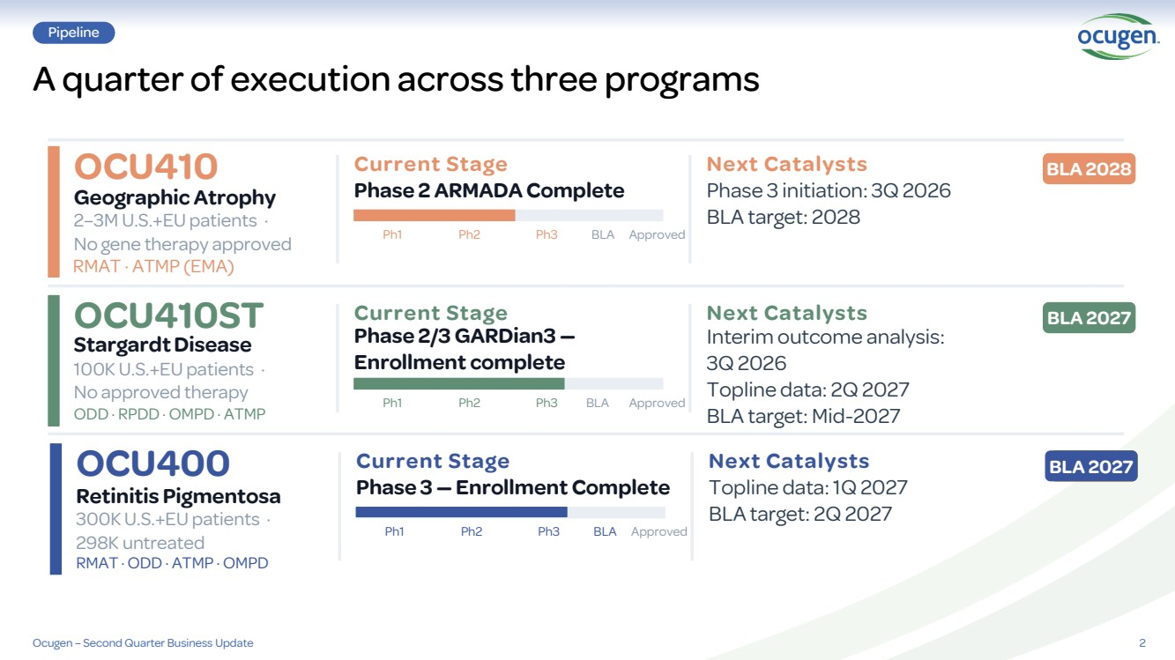 | 2 Pipeline A quarter of execution across three programs Ocugen – Second Quarter Business Update OCU410ST Stargardt Disease 100K U.S.+EU patients · No approved therapy ODD · RPDD · OMPD · ATMP Current Stage Phase 2/3 GARDian3 — Enrollment complete Ph1 Ph2 Ph3 BLA Approved Next Catalysts Interim outcome analysis: 3Q 2026 Topline data: 2Q 2027 BLA target: Mid-2027 BLA 2027 OCU400 Retinitis Pigmentosa 300K U.S.+EU patients · 298K untreated RMAT · ODD · ATMP · OMPD Current Stage Phase 3 — Enrollment Complete Ph1 Ph2 Ph3 BLA Approved Next Catalysts Topline data: 1Q 2027 BLA target: 2Q 2027 BLA 2027 OCU410 Geographic Atrophy 2–3M U.S.+EU patients · No gene therapy approved RMAT · ATMP (EMA) Current Stage Phase 2 ARMADA Complete Ph1 Ph2 Ph3 BLA Approved Next Catalysts Phase 3 initiation: 3Q 2026 BLA target: 2028 BLA 2028
 | 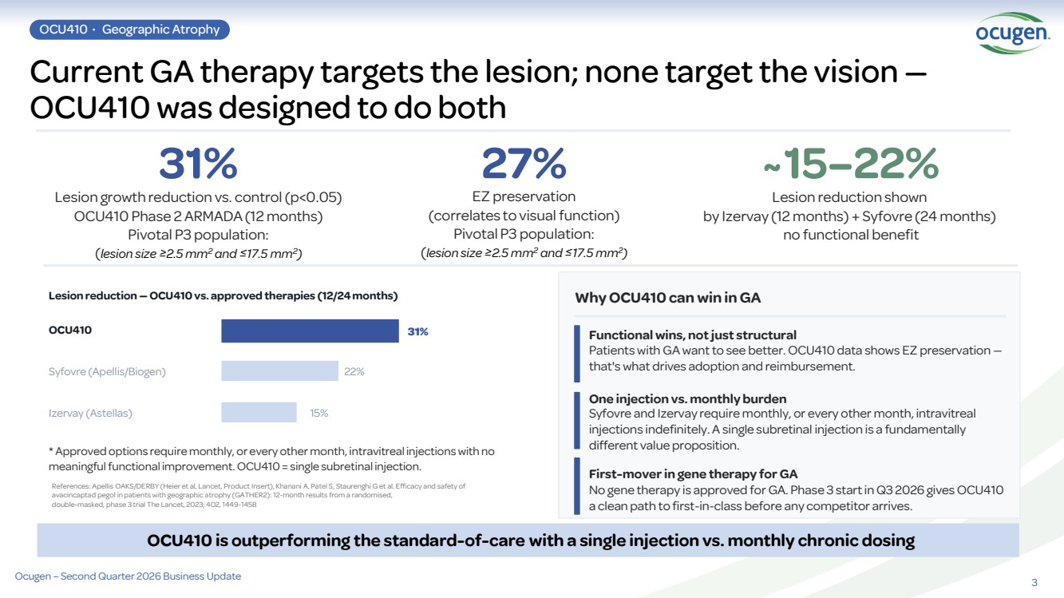 | 3 Current GA therapy targets the lesion; none target the vision — OCU410 was designed to do both 31% Lesion growth reduction vs. control (p<0.05) OCU410 Phase 2 ARMADA (12 months) Pivotal P3 population: (lesion size ≥2.5 mm2 and ≤17.5 mm2 ) 27% EZ preservation (correlates to visual function) Pivotal P3 population: (lesion size ≥2.5 mm2 and ≤17.5 mm2 ) ~15–22% Lesion reduction shown by Izervay (12 months) + Syfovre (24 months) no functional benefit Lesion reduction — OCU410 vs. approved therapies (12/24 months) OCU410 31% Syfovre (Apellis/Biogen) 22% Izervay (Astellas) 15% * Approved options require monthly, or every other month, intravitreal injections with no meaningful functional improvement. OCU410 = single subretinal injection. Why OCU410 can win in GA Functional wins, not just structural Patients with GA want to see better. OCU410 data shows EZ preservation — that's what drives adoption and reimbursement. One injection vs. monthly burden Syfovre and Izervay require monthly, or every other month, intravitreal injections indefinitely. A single subretinal injection is a fundamentally different value proposition. First-mover in gene therapy for GA No gene therapy is approved for GA. Phase 3 start in Q3 2026 gives OCU410 a clean path to first-in-class before any competitor arrives. OCU410 is outperforming the standard-of-care with a single injection vs. monthly chronic dosing References: Apellis OAKS/DERBY (Heier et al, Lancet, Product Insert), Khanani A, Patel S, Staurenghi G et al. Efficacy and safety of avacincaptad pegol in patients with geographic atrophy (GATHER2): 12-month results from a randomised, double-masked, phase 3 trial The Lancet, 2023; 402, 1449-1458 OCU410 · Geographic Atrophy Ocugen – Second Quarter 2026 Business Update
 | 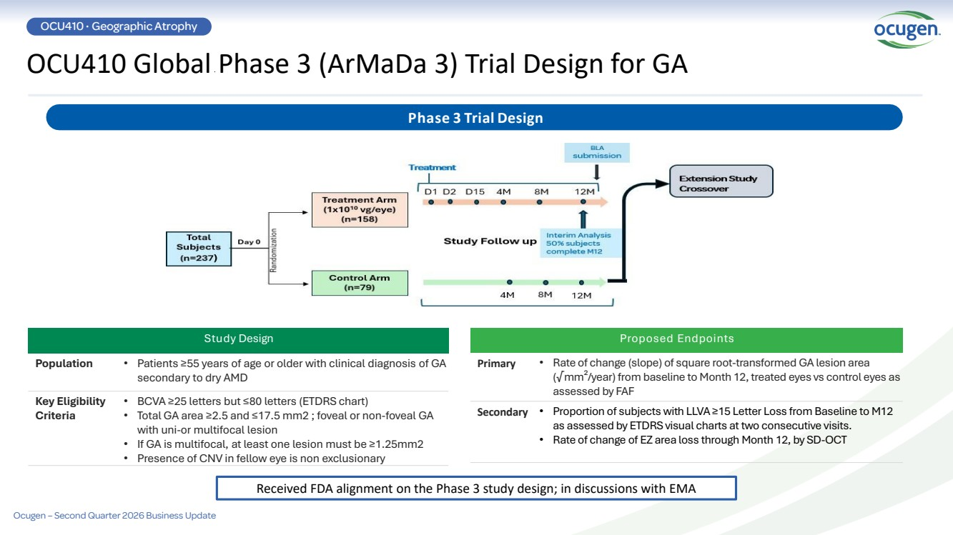 | Proposed Endpoints Primary • Rate of change (slope) of square root-transformed GA lesion area (√mm²/year) from baseline to Month 12, treated eyes vs control eyes as assessed by FAF Secondary • Proportion of subjects with LLVA ≥15 Letter Loss from Baseline to M12 as assessed by ETDRS visual charts at two consecutive visits. • Rate of change of EZ area loss through Month 12, by SD-OCT Phase 3 Trial Design Study Design Population • Patients ≥55 years of age or older with clinical diagnosis of GA secondary to dry AMD Key Eligibility Criteria • BCVA ≥25 letters but ≤80 letters (ETDRS chart) • Total GA area ≥2.5 and ≤17.5 mm2 ; foveal or non-foveal GA with uni-or multifocal lesion • If GA is multifocal, at least one lesion must be ≥1.25mm2 • Presence of CNV in fellow eye is non exclusionary OCU410 Global Phase 3 (ArMaDa 3) Trial Design for GA OCU410 · Geographic Atrophy Ocugen – Second Quarter 2026 Business Update Received FDA alignment on the Phase 3 study design; in discussions with EMA
 | 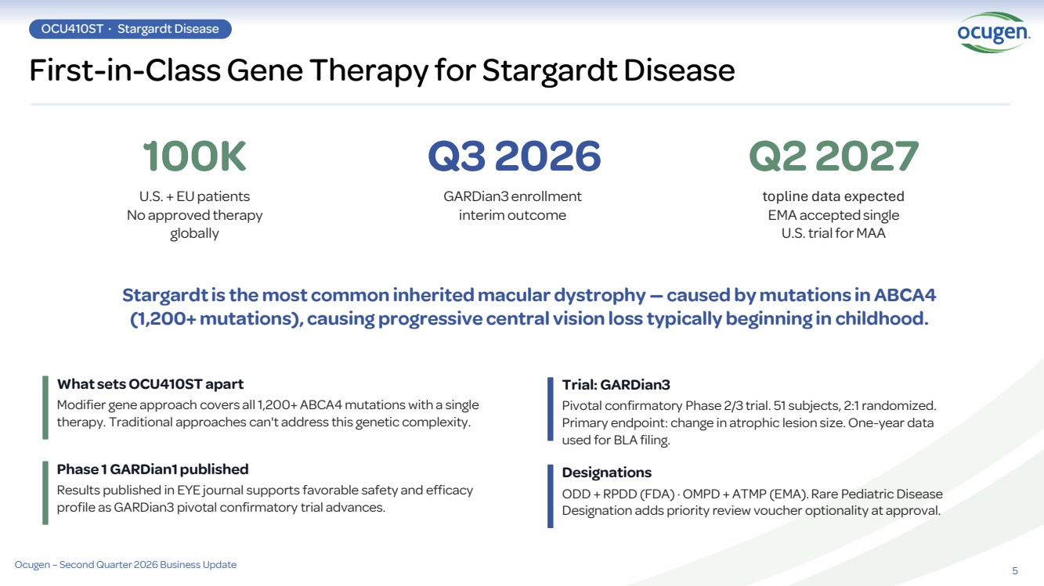 | 5 First-in-Class Gene Therapy for Stargardt Disease OCU410ST · Stargardt Disease 100K U.S. + EU patients No approved therapy globally Q3 2026 GARDian3 enrollment interim outcome Q2 2027 topline data expected EMA accepted single U.S. trial for MAA Stargardt is the most common inherited macular dystrophy — caused by mutations in ABCA4 (1,200+ mutations), causing progressive central vision loss typically beginning in childhood. What sets OCU410ST apart Modifier gene approach covers all 1,200+ ABCA4 mutations with a single therapy. Traditional approaches can't address this genetic complexity. Phase 1 GARDian1 published Results published in EYE journal supports favorable safety and efficacy profile as GARDian3 pivotal confirmatory trial advances. Pivotal confirmatory Phase 2/3 trial. 51 subjects, 2:1 randomized. Primary endpoint: change in atrophic lesion size. One-year data used for BLA filing. ODD + RPDD (FDA) · OMPD + ATMP (EMA). Rare Pediatric Disease Designation adds priority review voucher optionality at approval. Trial: GARDian3 Designations Ocugen – Second Quarter 2026 Business Update
 | 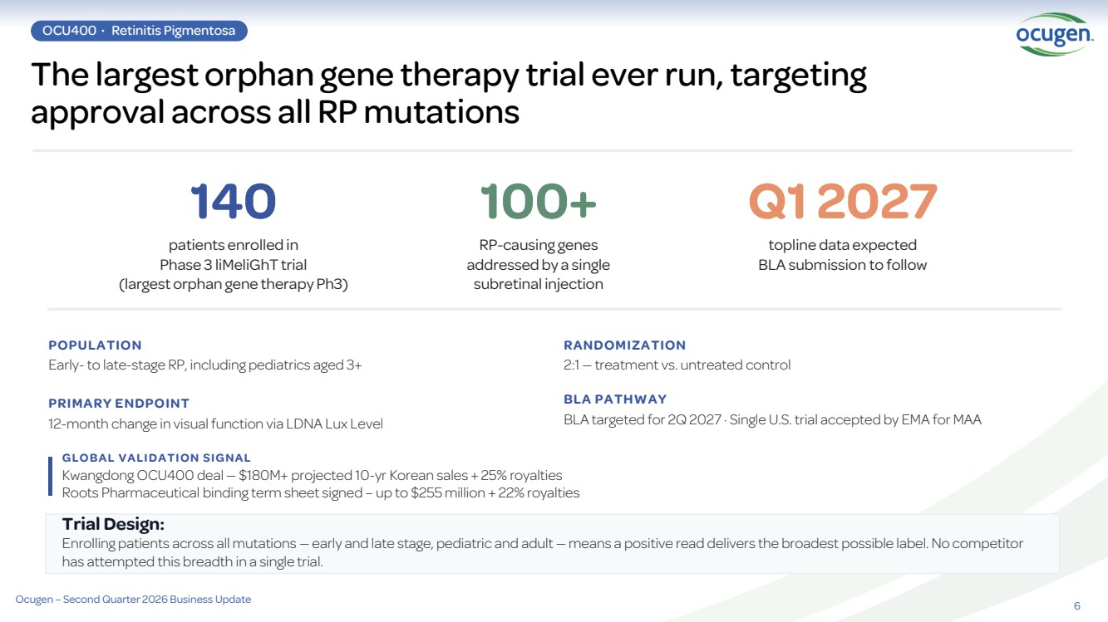 | 6 The largest orphan gene therapy trial ever run, targeting approval across all RP mutations OCU400 · Retinitis Pigmentosa 140 patients enrolled in Phase 3 liMeliGhT trial (largest orphan gene therapy Ph3) 100+ RP-causing genes addressed by a single subretinal injection Q1 2027 topline data expected BLA submission to follow POPULATION Early- to late-stage RP, including pediatrics aged 3+ PRIMARY ENDPOINT 12-month change in visual function via LDNA Lux Level RANDOMIZATION 2:1 — treatment vs. untreated control BLA PATHWAY BLA targeted for 2Q 2027 · Single U.S. trial accepted by EMA for MAA Trial Design: Enrolling patients across all mutations — early and late stage, pediatric and adult — means a positive read delivers the broadest possible label. No competitor has attempted this breadth in a single trial. G L O B A L V A L I D A T I O N S I G N A L Kwangdong OCU400 deal — $180M+ projected 10-yr Korean sales + 25% royalties Roots Pharmaceutical binding term sheet signed – up to $255 million + 22% royalties Ocugen – Second Quarter 2026 Business Update
 | 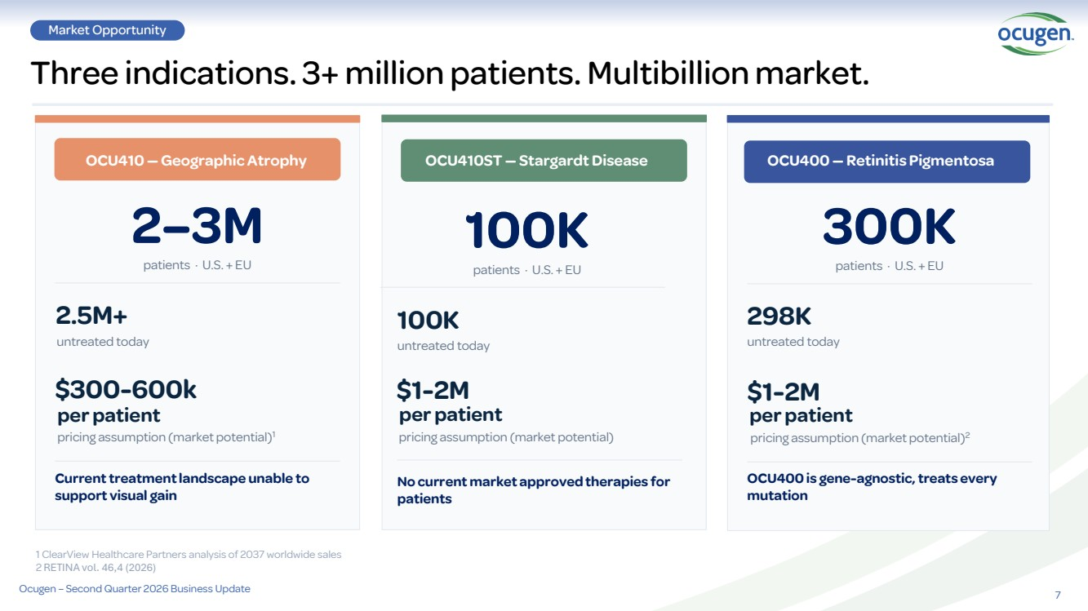 | 7 Three indications. 3+ million patients. Multibillion market. Market Opportunity OCU410 — Geographic Atrophy 2–3M patients · U.S. + EU 2.5M+ untreated today $300-600k pricing assumption (market potential)1 Current treatment landscape unable to support visual gain OCU410ST — Stargardt Disease 100K patients · U.S. + EU 100K untreated today $1-2M No current market approved therapies for patients Ocugen – Second Quarter 2026 Business Update per patient per patient pricing assumption (market potential) OCU400 — Retinitis Pigmentosa 300K patients · U.S. + EU 298K untreated today $1-2M OCU400 is gene-agnostic, treats every mutation pricing assumption (market potential)2 per patient 1 ClearView Healthcare Partners analysis of 2037 worldwide sales 2 RETINA vol. 46,4 (2026)
 | 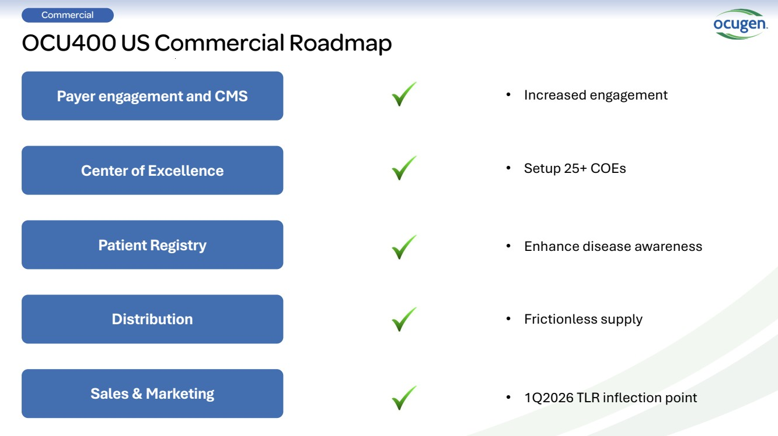 | OCU400 US Commercial Roadmap Payer engagement and CMS Center of Excellence Patient Registry Distribution Sales & Marketing • Increased engagement • Setup 25+ COEs • Enhance disease awareness • Frictionless supply • 1Q2026 TLR inflection point Commercial
 | 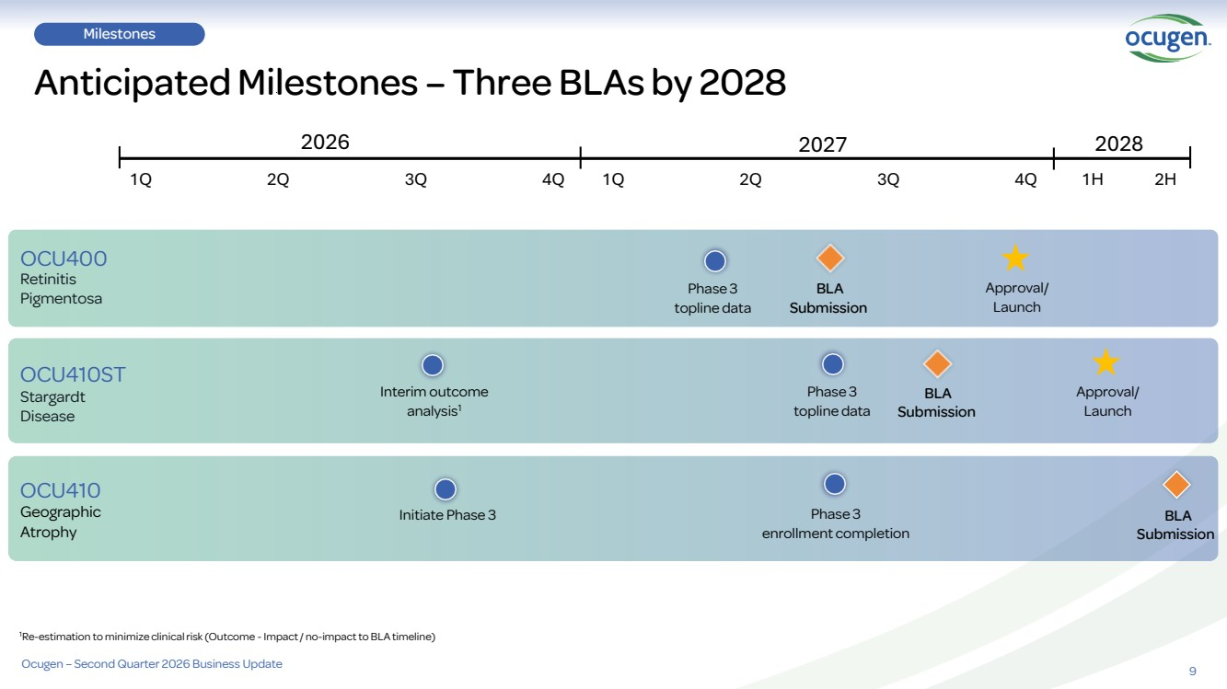 | 9 Milestones Anticipated Milestones – Three BLAs by 2028 Retinitis Pigmentosa Stargardt Disease Geographic Atrophy OCU400 OCU410ST OCU410 Interim outcome analysis1 Phase 3 topline data Initiate Phase 3 2026 2027 1Q 2Q 3Q 4Q Phase 3 topline data BLA Submission Approval/ Launch Approval/ Launch BLA Submission 1H 2H 2028 Phase 3 enrollment completion 1Re-estimation to minimize clinical risk (Outcome -Impact / no-impact to BLA timeline) 1Q 2Q 3Q 4Q BLA Submission Ocugen – Second Quarter 2026 Business Update
 | 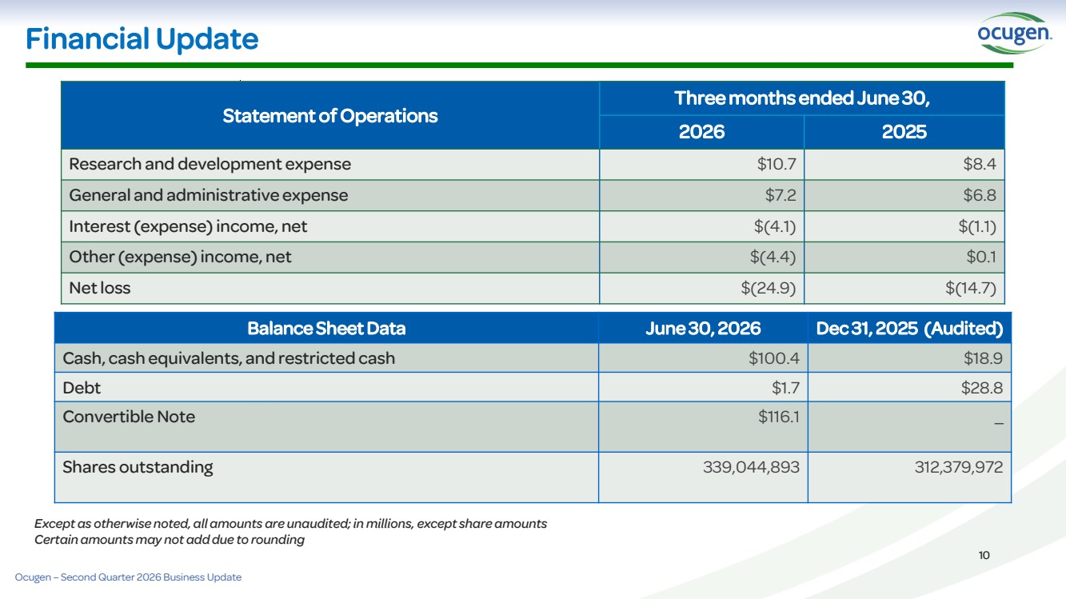 | Financial Update Statement of Operations Three months ended June 30, 2026 2025 Research and development expense $10.7 $8.4 General and administrative expense $7.2 $6.8 Interest (expense) income, net $(4.1) $(1.1) Other (expense) income, net $(4.4) $0.1 Net loss $(24.9) $(14.7) Balance Sheet Data June 30, 2026 Dec 31, 2025 (Audited) Cash, cash equivalents, and restricted cash $100.4 $18.9 Debt $1.7 $28.8 Convertible Note $116.1 _ Shares outstanding 339,044,893 312,379,972 10 Except as otherwise noted, all amounts are unaudited; in millions, except share amounts Certain amounts may not add due to rounding Ocugen – Second Quarter 2026 Business Update
 | 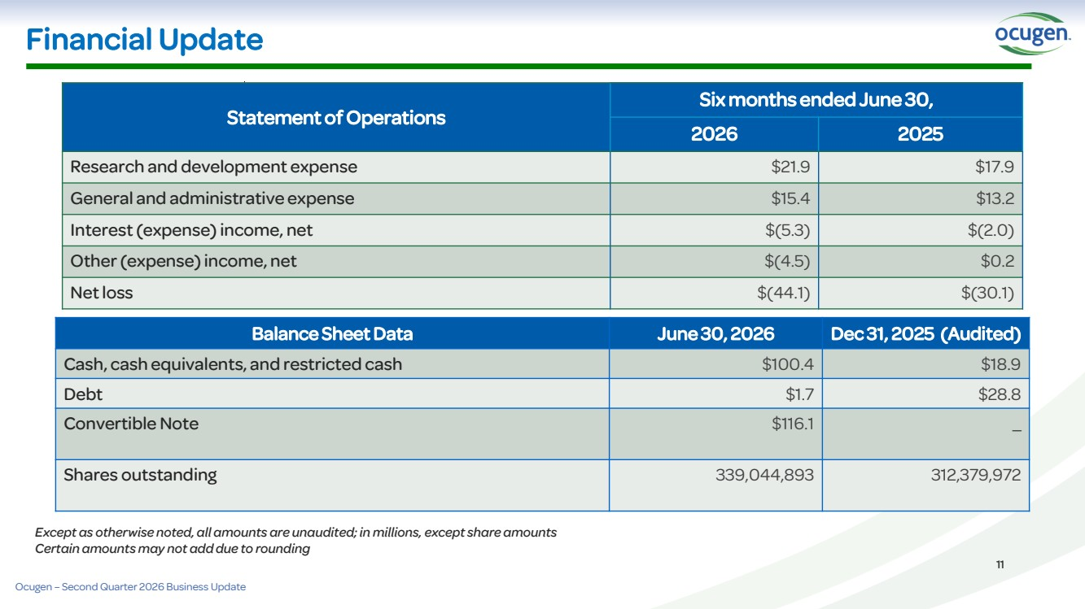 | Financial Update Statement of Operations Six months ended June 30, 2026 2025 Research and development expense $21.9 $17.9 General and administrative expense $15.4 $13.2 Interest (expense) income, net $(5.3) $(2.0) Other (expense) income, net $(4.5) $0.2 Net loss $(44.1) $(30.1) Balance Sheet Data June 30, 2026 Dec 31, 2025 (Audited) Cash, cash equivalents, and restricted cash $100.4 $18.9 Debt $1.7 $28.8 Convertible Note $116.1 _ Shares outstanding 339,044,893 312,379,972 11 Except as otherwise noted, all amounts are unaudited; in millions, except share amounts Certain amounts may not add due to rounding Ocugen – Second Quarter 2026 Business Update

